**Research**



[File:Home free icon.svg - Wikimedia Commons](https://commons.wikimedia.org/wiki/File:Home_free_icon.svg)



[Free Cog Icon - Download in Glyph Style (iconscout.com)](https://iconscout.com/free-icon/cog-wheel-gear-setting)

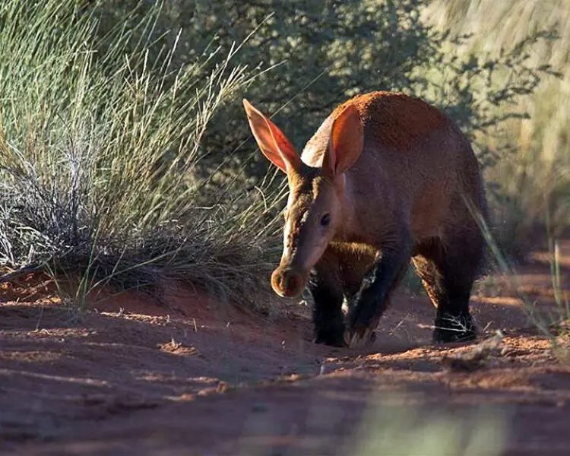

[Aardvark - Facts, Diet, Habitat & Pictures on Animalia.bio](https://animalia.bio/aardvark)

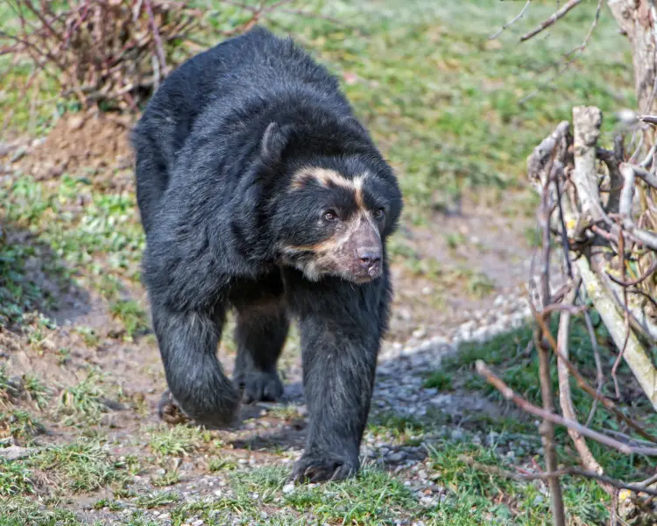

[Spectacled Bear - Facts, Diet, Habitat & Pictures on Animalia.bio](https://www.animalia.bio/spectacled-bear)

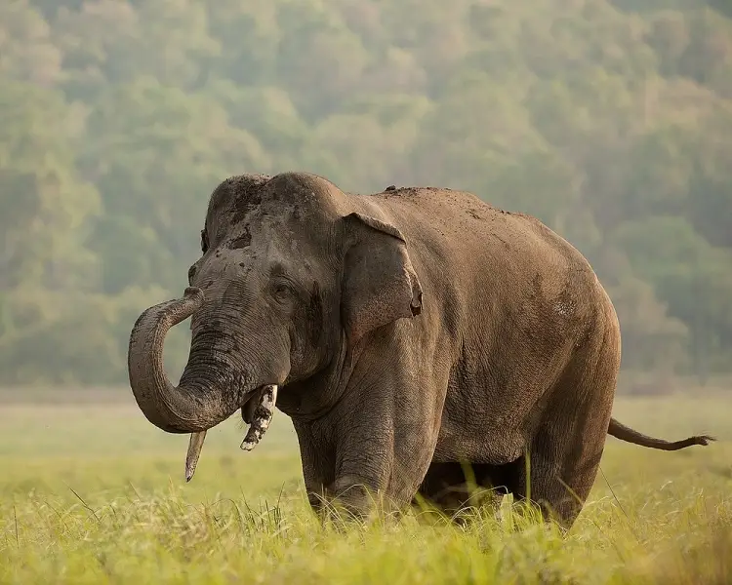

[Asian Elephant - Facts, Diet, Habitat & Pictures on Animalia.bio](https://animalia.bio/asian-elephant)

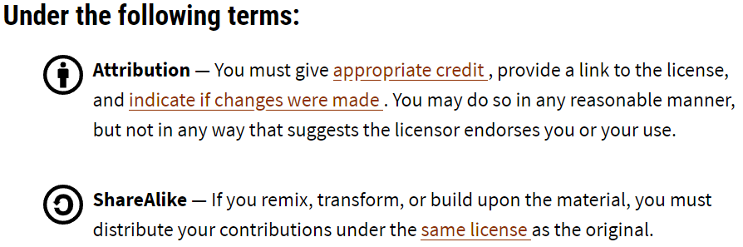

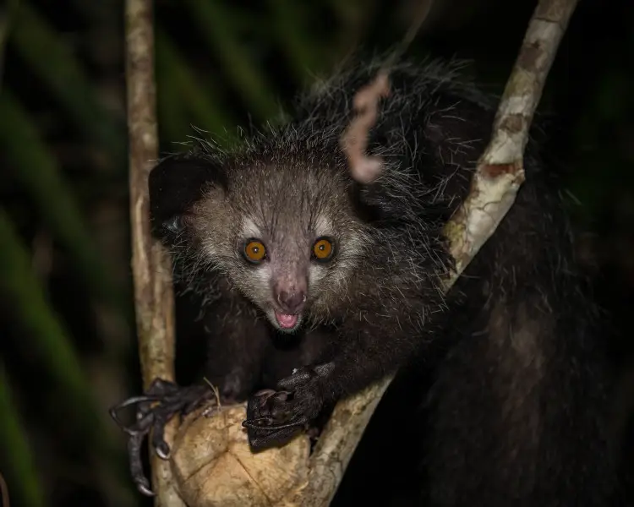

[Aye-Aye - Facts, Diet, Habitat & Pictures on Animalia.bio](https://animalia.bio/aye-aye)



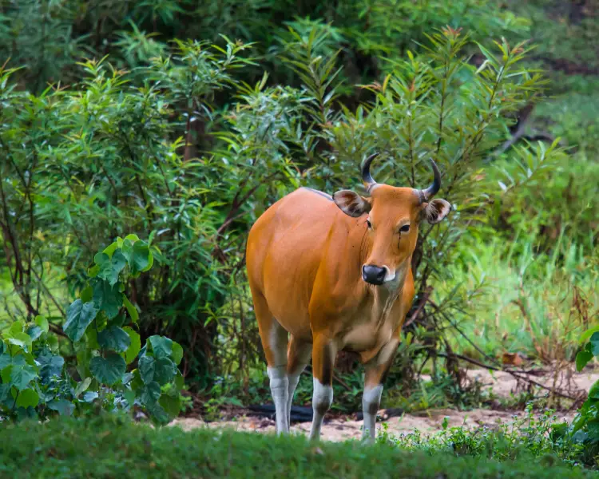

[Banteng - Facts, Diet, Habitat & Pictures on Animalia.bio](https://animalia.bio/banteng)



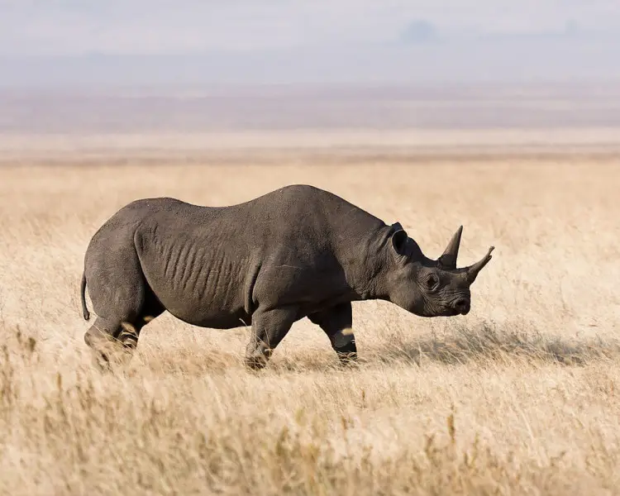

[Black Rhinoceros - Facts, Diet, Habitat & Pictures on Animalia.bio](https://animalia.bio/black-rhinoceros)



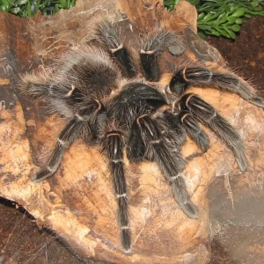

[Brazilian Salmon Pink Crab - Facts, diet, habitat and photos on Animalia.bio](https://animalia.bio/pt/lasiodora-parahybana)



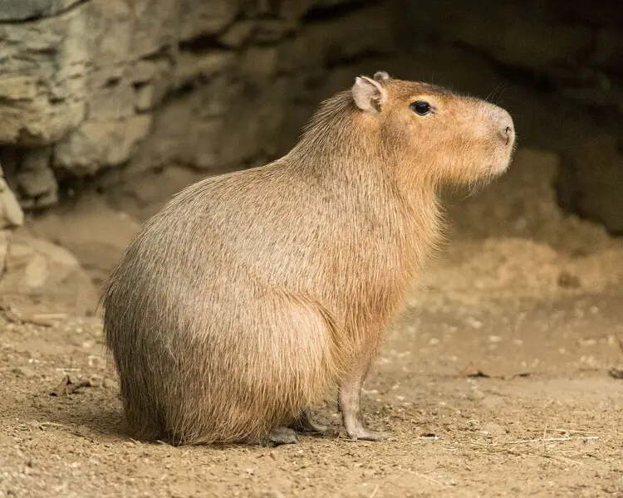

[Capybara - Facts, Diet, Habitat & Pictures on Animalia.bio](https://animalia.bio/capybara)



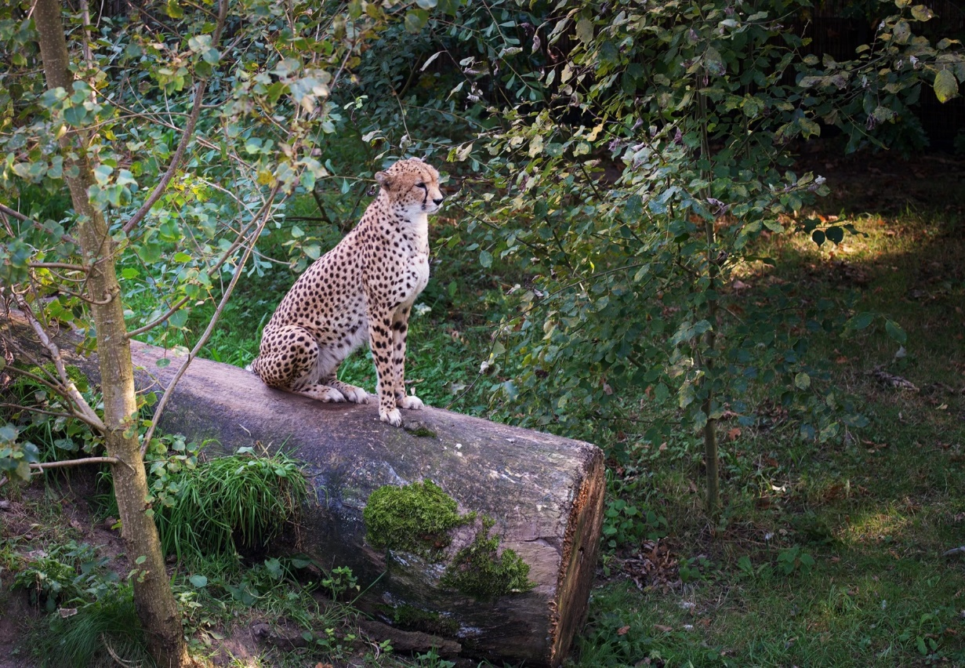

[Northwest African Cheetah - Facts, Diet, Habitat & Pictures on Animalia.bio](https://animalia.bio/northwest-african-cheetah)



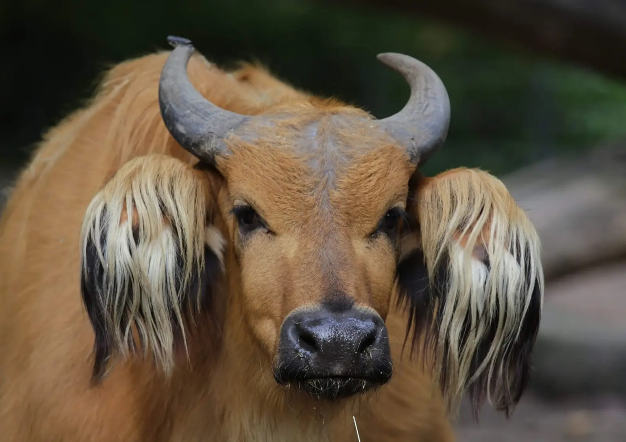

[African forest buffalo - Facts, Diet, Habitat & Pictures on Animalia.bio](https://animalia.bio/african-forest-buffalo)

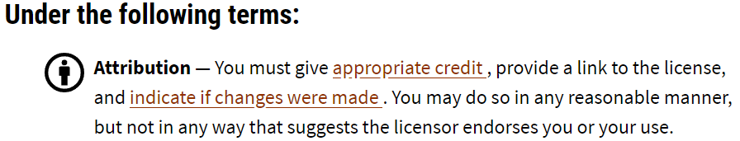

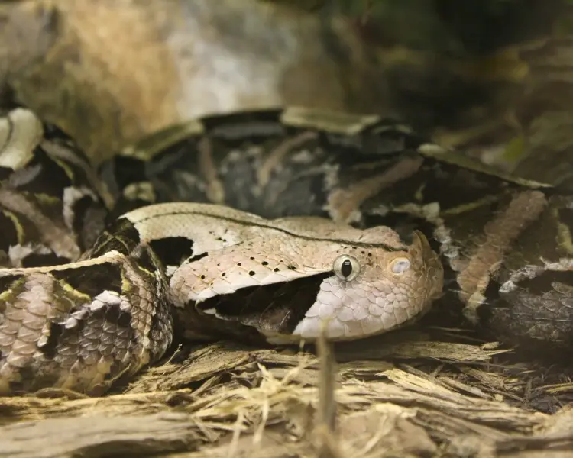

[Gaboon Viper - Facts, Diet, Habitat & Pictures on Animalia.bio](https://animalia.bio/gaboon-viper)



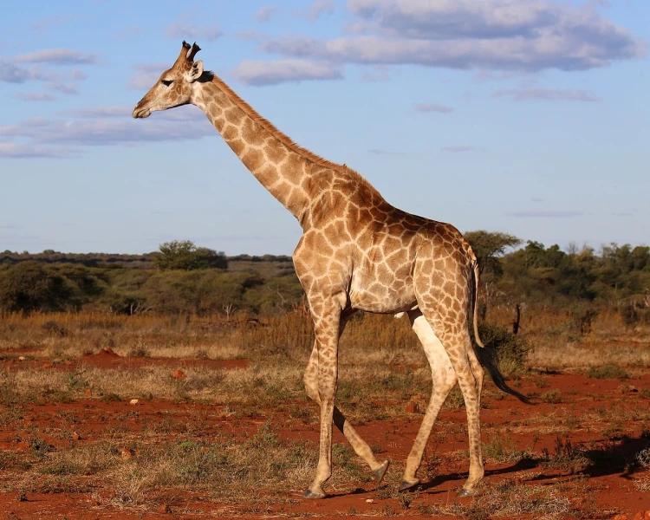

[South African Giraffe - Facts, Diet, Habitat & Pictures on Animalia.bio](https://animalia.bio/south-african-giraffe)



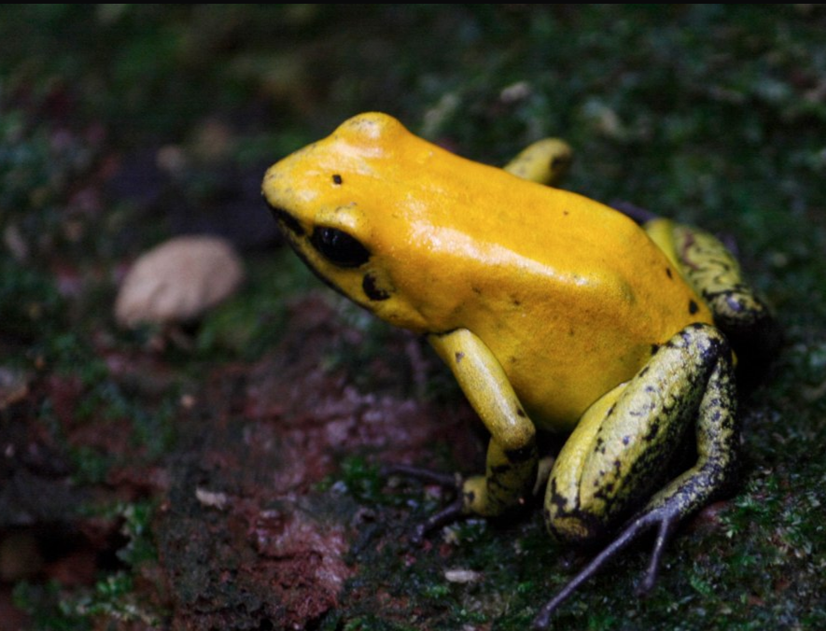

[Golden Poison Dart Frog | Phyllobates terribilis | Flickr](https://www.flickr.com/photos/timstadelmann/3627080592)



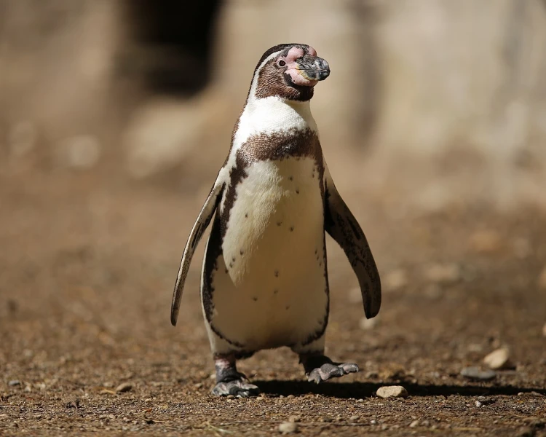

[Humboldt Penguin - Facts, Diet, Habitat & Pictures on Animalia.bio](https://animalia.bio/humboldt-penguin)



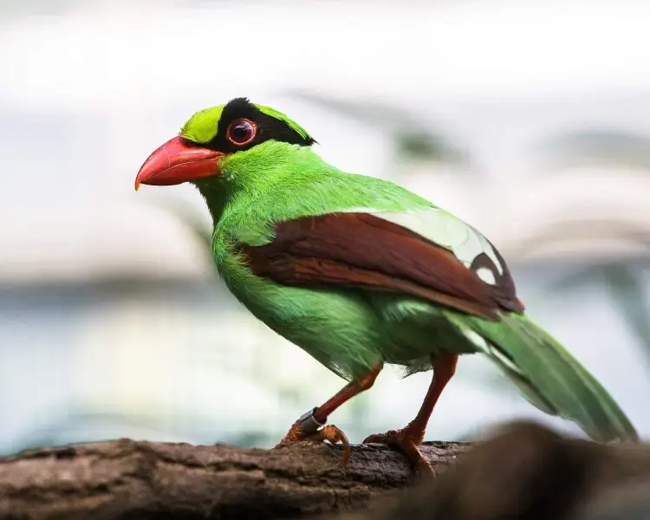

[Javan green magpie - Facts, Diet, Habitat & Pictures on Animalia.bio](https://animalia.bio/javan-green-magpie)



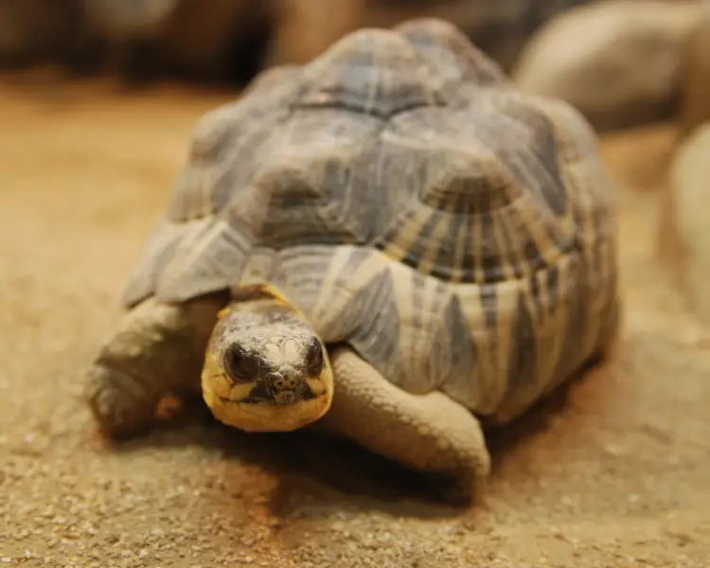

[Radiated Tortoise - Facts, Diet, Habitat & Pictures on Animalia.bio](https://animalia.bio/radiated-tortoise)



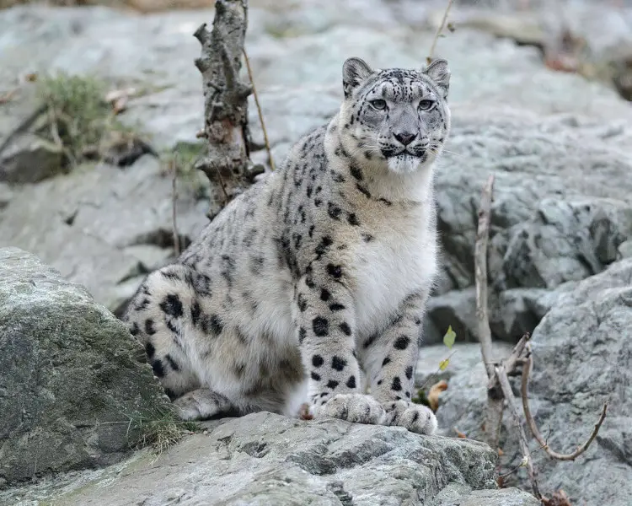

[Snow Leopard - Facts, Diet, Habitat & Pictures on Animalia.bio](https://animalia.bio/snow-leopard)



* Snow leopard
  + [Snow Leopard Facts - Snow Leopard Trust](https://snowleopard.org/snow-leopard-facts/)
  + ICUN Red List – vulnerable.
  + Diet – carnivore (eats sheep and goats).
  + Habitat – the mountains of Central Asia.
  + Fun facts – they are solo travellers (solitary and highly elusive), they are crepuscular (most active at dawn and dusk), they are single mothers (raise cubs alone) and they are gentle (they aren’t known for being aggressive towards humans.

[About CC Licenses - Creative Commons](https://creativecommons.org/share-your-work/cclicenses/)